

**INSTALLATION MANUAL**

**Table of Contents**

**1.** **Applicable Version**…………..…....……………………………….………………………...2

**2.** **Installation kit**..………………….……….……………………………………………………..3

**3.** **Configuring Ingenico**……………….…………………………………………………………4

4. **Feature List**……………….……………………………………………………………………..…5

**Applicable Versions**

|  |  |
| --- | --- |
| **Applications** | **Versions** |
| Composer | 2.0.13 |
| Laravel Installer | 4.2.5 |

### 

|  |  |
| --- | --- |
| **Applications** | **Versions** |
| PHP | ≥ 7.1.3, < 8.0 |
| Laravel Framework | 5.8.38 |

### 

|  |  |
| --- | --- |
| **Applications** | **Versions** |
| PHP | ≥ 7.3.0, < 8.2 |
| Laravel Framework | 8.44.0 |

### 

**Installation Kit**

Please follow the given steps to install and run the Ingenico Payment Gateway module

1. Browse the provided zip folder and click it and download it .

2. Unzip that folder and place into www or htdocs folder

3. Install dependency through composer.

4. Open command prompt

5. Go to that folder “cd xampp\htdocs\unzip_folder”

6. Enter the command “php artisan serve”

7. You will get link copy that and open on your browser

8. for start of Ingenico kit  [http://<your-hostname>/start](http://127.0.0.1:8000/start)

**Update kit**

1. Go to the “\xampp\htdocs\unzip_folder” delete the old folder from htdocs and put the new folder there.

2. Follow the same process as mentioned above.

**Configuring Ingenico**

1. Go-to admin Page [http://<your-hostname>/admin](http://127.0.0.1:8000/admin)
2. Scroll down. You will see ingenico, Edit it
3. Configure it as below:

|  |  |
| --- | --- |
| **Column Name** | **Description** |
| Merchant Code | Enter Merchant Code |
| Salt | Enter Salt. |
| Payment Type | For Test mode Select ‘Test’ and for Live mode select ‘Live’ |
| Merchant Scheme Code | Enter Scheme Code |

4. Now click on “Submit” on the bottom-right corner.

5. Ingenico Payment Gateway is now configured & ready to use.

**Advanced Configuration**

There are also some advanced configuration options you may consider as shown below:

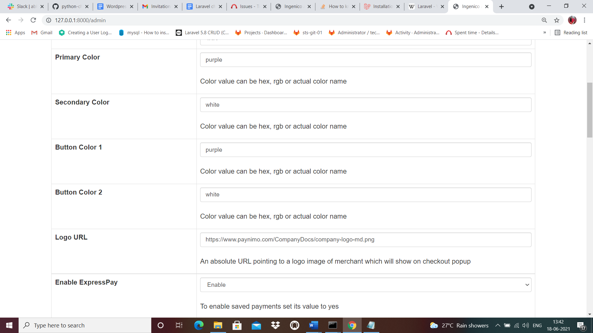

**Features List**

**Online Transaction:**

To make an online transaction go to http://<your-hostname>/start .

**Dual verification of response:**

We are validating responses with a hash value and call again Payment Gateway for dual verification from the payment gateway before updating to the order status.

**S2S Verification**

If we do not receive any response from the payment gateway then after 30 mins, we will get a response from the server and based on the response it will update order status. To configure S2S URL, contact prod team.

S2S url format : http://<your-hostname>/s2s?msg=

Example:

http://<your-hostname>/s2s?msg=0300|success|NA|12846079|470|1411243270|5.00|{itc:}{c[%E2%80%A6]f93dd72dc9c05fa0fa1601fb85d74d3e3177e7b2f3f111b08f542681077cq

**MCG**

It supports multi currency like INR & USD and a lot more can be added.

**Ingenico Offline Verification**

Merchants can verify the status of their payment by using the Payment Verification page. The payment verification page can be found at [http://<your-hostname>/offline_verification](http://localhost:3000/payment/offline-verification)

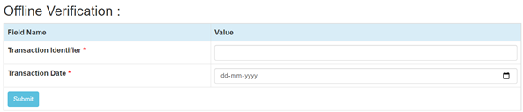

**Reconciliation**

Merchants can update the pending status of the order automatically if the payments are successful. This page can be found at [http://<your-hostname>/reconciliation](http://localhost:3000/payment/reconcile)

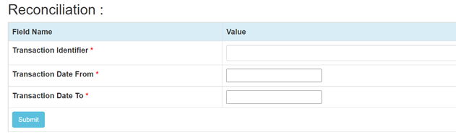

**Refund**

Merchants should be able to process the refund online for the order whose payment has been done via Ingenico. To refund an order go to [http://<your-hostname>/refund](http://localhost:3000/payment/refund)

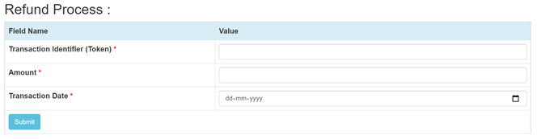

**Embed Payment Gateway On Page**

After enabling this setting, payment gateway displays like embedded on the page instead of pop-up so user experience would be good.

**E-mandate/E-Nach/SI**

**Configuration**

1. Go-to http://<your-hostname>/admin
2. Configure it as below

|  |  |
| --- | --- |
| **Column Name** | **Description** |
| Enable eMandate/SI | “Enable” this flag to use E-mandate/E-nach/SI |

1. Now click on “submit” on the bottom.
2. Ingenico Payment Gateway with E-mandate is now configured & ready to use.

**Advanced Configuration**

There are also some advanced configuration options you may consider as shown below:

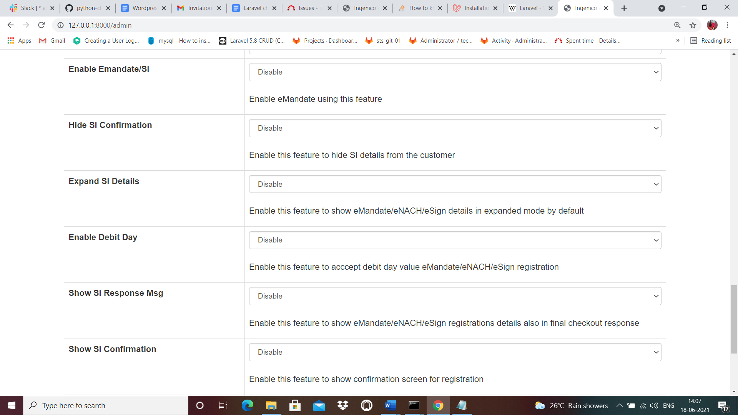

**Mandate Registration**

1. Go-to http://<your-hostname>/start
2. Fill the necessary fields for transaction
3. Click on “Submit” button to get the E-mandate Pop up
4. Fill the necessary fields on pop -up and click complete the transaction to register the mandate

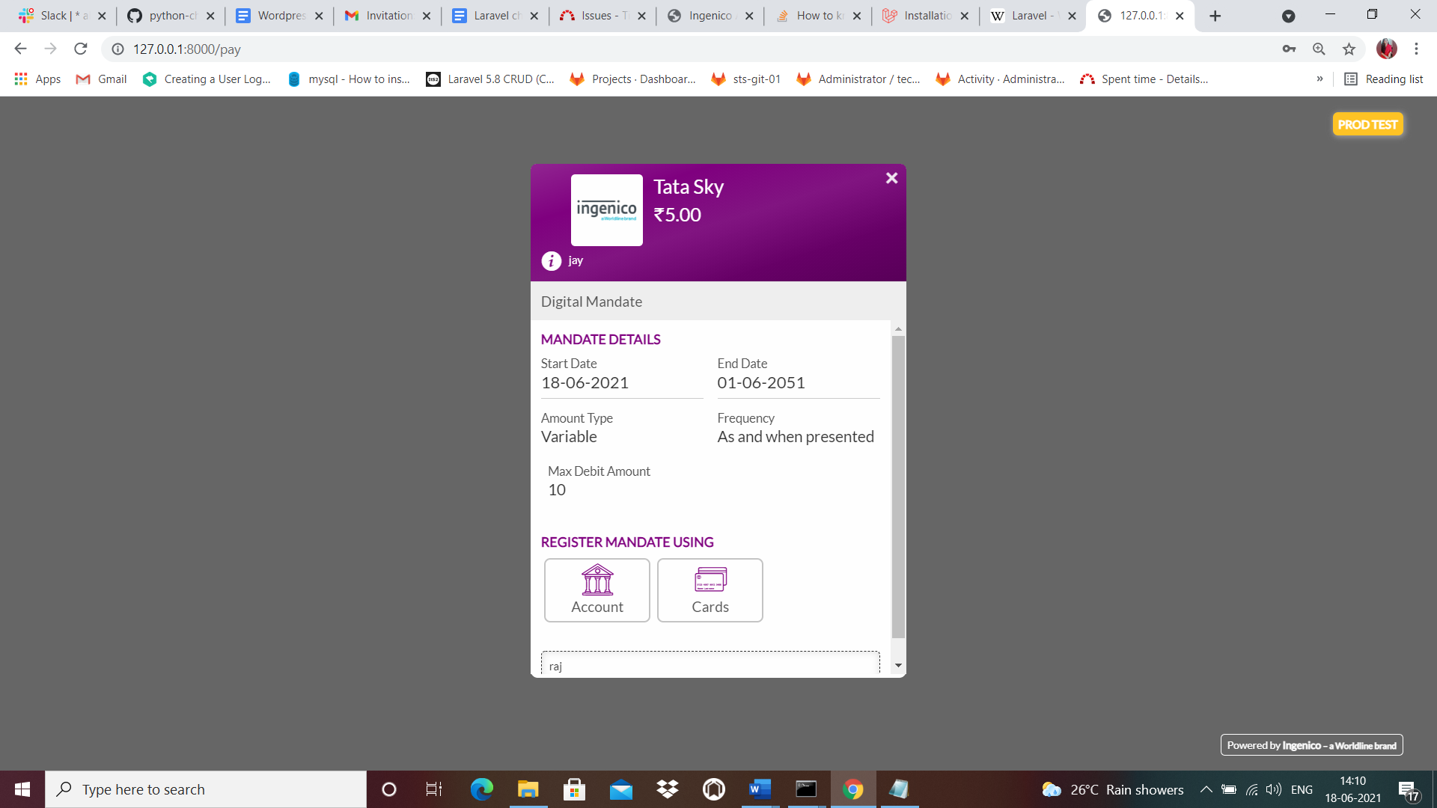

## **Features List**

**Mandate Verification**

Merchants can verify the status of their Registered Mandate/SI by using the Mandate Verification page.The Mandate verification page can be found at [http://<your-hostname>/](http://localhost:3000/payment/offline-verification)mandate_verification

We need to pass Consumer ID used in Online Transaction

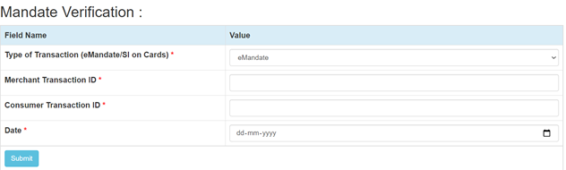

**Transaction Scheduling**

Merchants can Schedule their Transaction for Mandate/SI by using the Transaction Scheduling page. The Transaction Scheduling page can be found at

[http://<your-hostname>/](http://localhost:3000/payment/offline-verification)transaction_scheduling

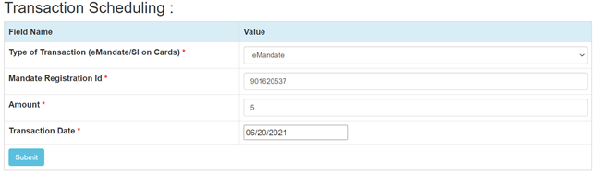

**Transaction Verification**

Merchants can verify the status of their Scheduled Transaction for Mandate/SI by using the Transaction Verification page. The Transaction Verification page can be found at

[http://<your-hostname>/](http://localhost:3000/payment/offline-verification)transaction_verification

We need to pass the Merchant Transaction Reg No given in Transaction Scheduling response

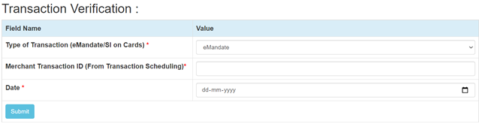

**Mandate Deactivation**

Merchants can deactivate the registered Transaction for Mandate/SI by using the Mandate Deactivation page. The Mandate Deactivation page can be found at

[http://<your-hostname>/](http://localhost:3000/payment/offline-verification)mandate_deactivation

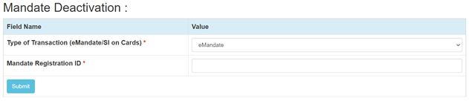

**Stop Payment**

Merchants can Stop the scheduled transaction by using the Stop Payment page. The Stop Payment page can be found at

[http://<your-hostname>/](http://localhost:3000/payment/offline-verification)stop_payment

We need to pass TPSL Transaction ID given in Transaction Scheduling response

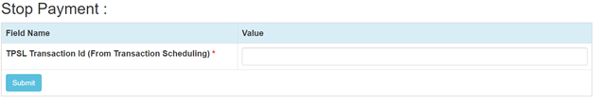

**Documentation link**

[**https://www.tecprocesssolution.com/proto/p2m/client/salt-based-documentation.htm#online**](https://www.tecprocesssolution.com/proto/p2m/client/salt-based-documentation.htm#online)